Experiment 11: Affine Transformation on an Image
Software / Tools: Python · OpenCV (cv2) · NumPy

AIM
To apply an Affine Transformation to an image, which preserves parallel lines while changing position, scale, and shear.
ALGORITHM
1. Import OpenCV and NumPy.
2. Read the input image and note its dimensions.
3. Select 3 reference points in the source image (pts1).
4. Define where those 3 points should map to in the output image (pts2).
5. Compute the affine transformation matrix using cv2.getAffineTransform(pts1, pts2).
6. Apply the matrix with cv2.warpAffine().
7. Display and save the transformed image.
PROGRAM (SOURCE CODE)
import cv2
import numpy as np

img = cv2.imread("image.jpg")
(h, w) = img.shape[:2]

pts1 = np.float32([[50, 50], [200, 50], [50, 200]])
pts2 = np.float32([[10, 100], [200, 50], [100, 250]])

M = cv2.getAffineTransform(pts1, pts2)
affine_result = cv2.warpAffine(img, M, (w, h))

cv2.imshow("Original", img)
cv2.imshow("Affine Transformed", affine_result)
cv2.waitKey(0)
cv2.destroyAllWindows()

OUTPUT
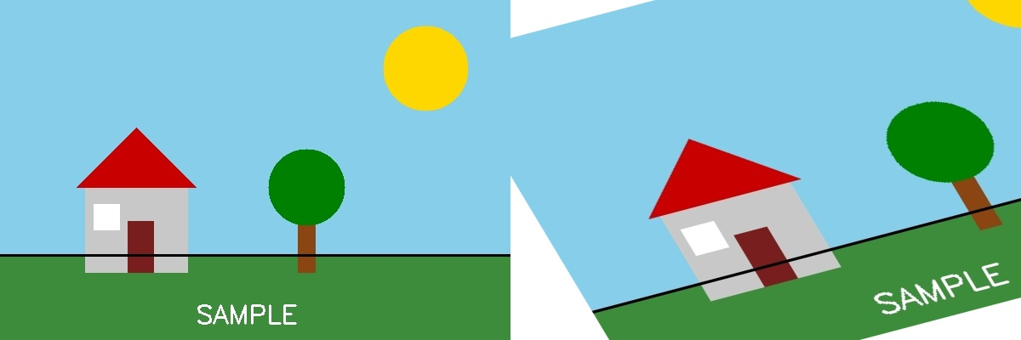
Fig. 11 — Output of Experiment 11: Affine Transformation on an Image.
RESULT
Apply an Affine Transformation to an image, which preserves parallel lines while changing position, scale, and shear — completed successfully, as demonstrated in the output shown above.

